Experiment-6
Student Name:Raj Kumar Singh UID: 23BCS11393
Branch: CSE Section/Group: KRG-3B
Semester: 6th Date of Performance: 02/03/26
Subject Name: System Design Subject Code: 23CSH-314

- AIM : To design an Youtube like platform

- Objective:
• To design a scalable and highly available video streaming system similar to YouTube.
• To understand how adaptive video streaming works using HLS and DASH with manifest files.
• To implement core features such as video upload, streaming, likes, comments, and user management.
• To design High-Level and Low-Level architecture ensuring performance, fault tolerance, and scalability.
• To apply system design principles like caching, CDN usage, database modeling, and API design in a real-world application.

- Tools Required:
• Frontend: HTML, CSS, JavaScript, React.js
• Backend: Node.js, Express.js
• Database: MongoDB
• API Testing: Postman
• Authentication: JWT
• Media Storage: Cloudinary / AWS S3
• Version Control: Git, GitHub
• Deployment: AWS / Render / Vercel

- SYSTEM DESIGN / SYSTEM SPECIFICATION:
  - Functional Requirements:
• User Registration & Login
• Upload Video
• Video Processing (transcoding)
• Watch Video (adaptive streaming)
• Like / Dislike Video
• Comment on Video
• Search Video
• Recommendation feed (basic)

  - Non-functional Requirements:
Requirement | Description
Scalability | Support millions of users
High Availability | 99.99% uptime
Low Latency | Video start < 2 sec
Durability | Uploaded video never lost
Fault Tolerance | Server failures handled
CDN Support | Fast global streaming
Security | Auth, rate limit, encryption
  - Core-Entites of the System:

  - User
  - Video
  - Likes
  - Commet

  - API Endpoints Creation:
A. Client-Onboarding
POST /api/v1/auth/signup
POST /api/v1/auth/login
POST /api/v1/auth/logout
GET /api/v1/auth/me

B. Video
Upload
POST /api/v1/videos

{
"title": "System Design Tutorial",
"description": "HLD and LLD explained",
"visibility": "public"
}

Get Video

GET /api/v1/videos/{videoId}
C. Streaming APIs (Manifest Based)

For HLS (.m3u8) and DASH (.mpd) streaming:
GET /api/v1/videos/{videoId}/manifest?type=hls
GET /api/v1/videos/{videoId}/manifest?type=dash
Response:
{
"manifest_url": "https://cdn.example.com/video123/master.m3u8"
}
After that, player directly fetches segments from CDN.

D. LIKE APIs
POST /api/v1/videos/{videoId}/like
DELETE /api/v1/videos/{videoId}/like
GET /api/v1/videos/{videoId}/likes/count

E. COMMENT APIs
Add Comment
POST /api/v1/videos/{videoId}/comments
Body:
{
"text": "Great explanation!",
"parent_id": null
}

F. SEARCH APIs
GET /api/v1/search?q=system+design&type=video
GET /api/v1/search?q=tech&type=channel

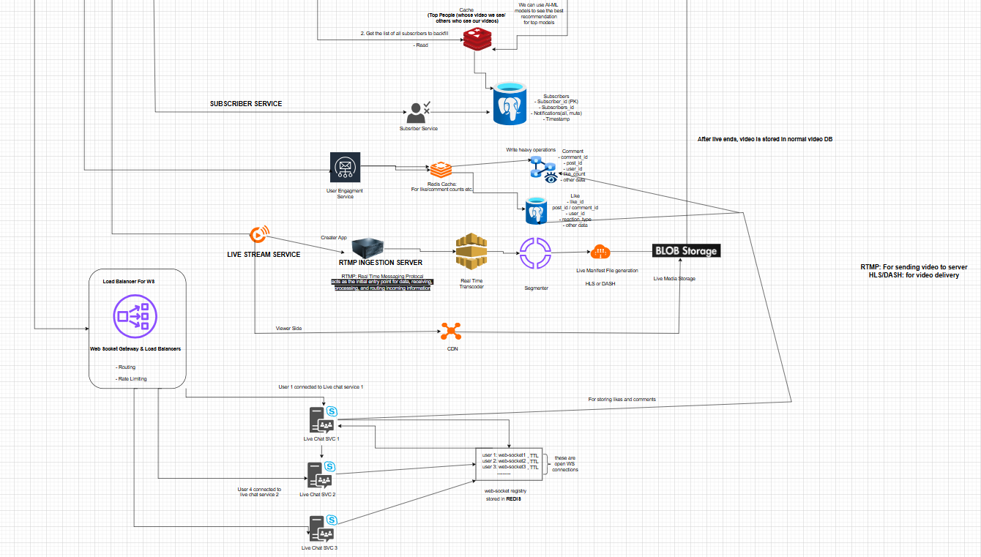
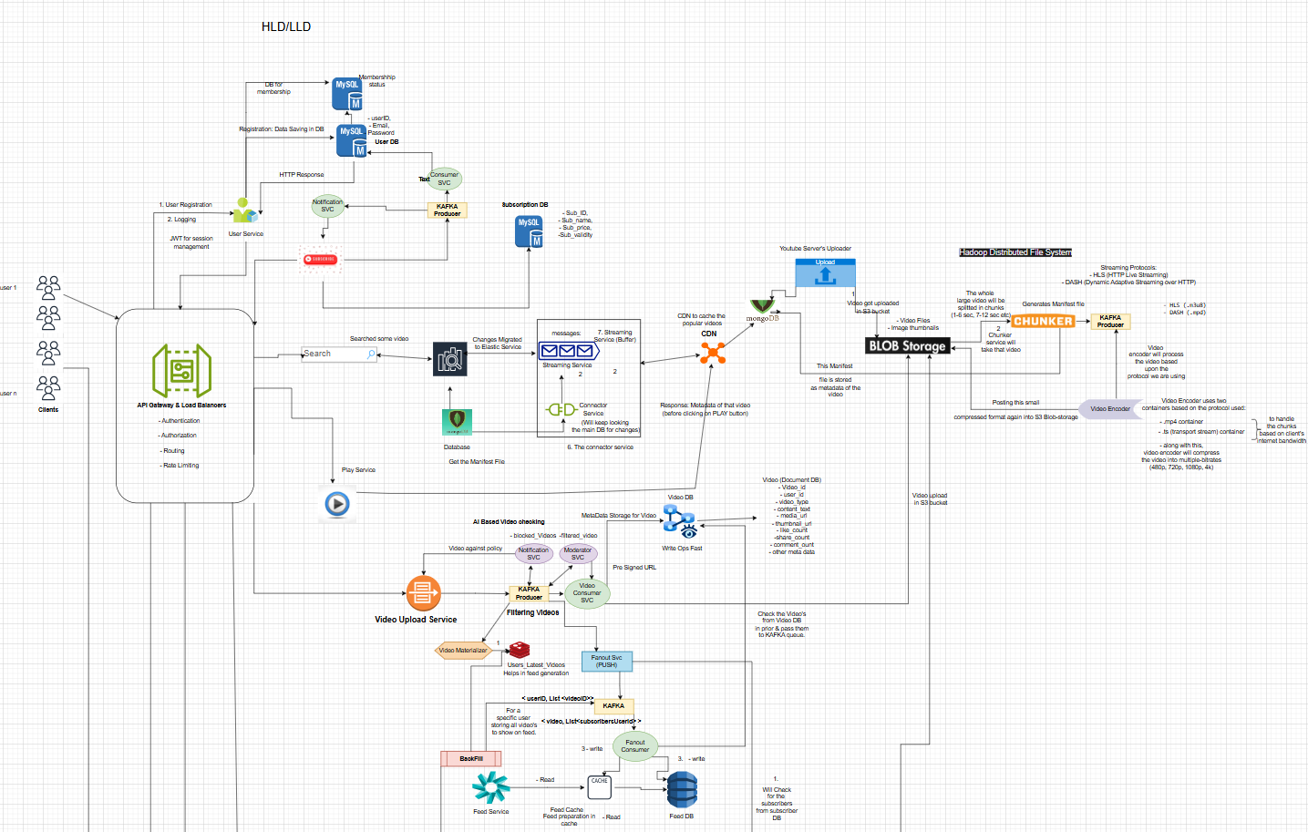
- HLD & LLD:

- Learning Outcomes

• Understand how large-scale video streaming platforms like YouTube are architected using distributed system principles.
• Learn how adaptive streaming works using HLS and DASH protocols with manifest files.
• Gain practical knowledge of designing scalable APIs, database schemas, and microservices architecture.
• Develop understanding of handling high-traffic features like likes, comments, and view counts efficiently using caching and sharding.
• Improve skills in creating HLD and LLD diagrams using Draw.io for real-world system design problems.

